“GTU Cyclothon-2020” organized by GTU
to embody
Our Honorable Prime Minister Narendra Modi's motto
"Hum Fit to Bharat Fit" "Fit Nation Hit Nation"
““फिटनेस का डोज़ - आधा घंटा रोज़".
Date: 30/12/2020 Time: 03:30 PM

Venue
Gujarat Technological University
B-0, Conference Hall, GTU Chandkheda Campus, Nr. Visat Three Roads, Visat - Gandhinagar Highway, Chandkheda, Ahmedabad – 382424 – Gujarat.

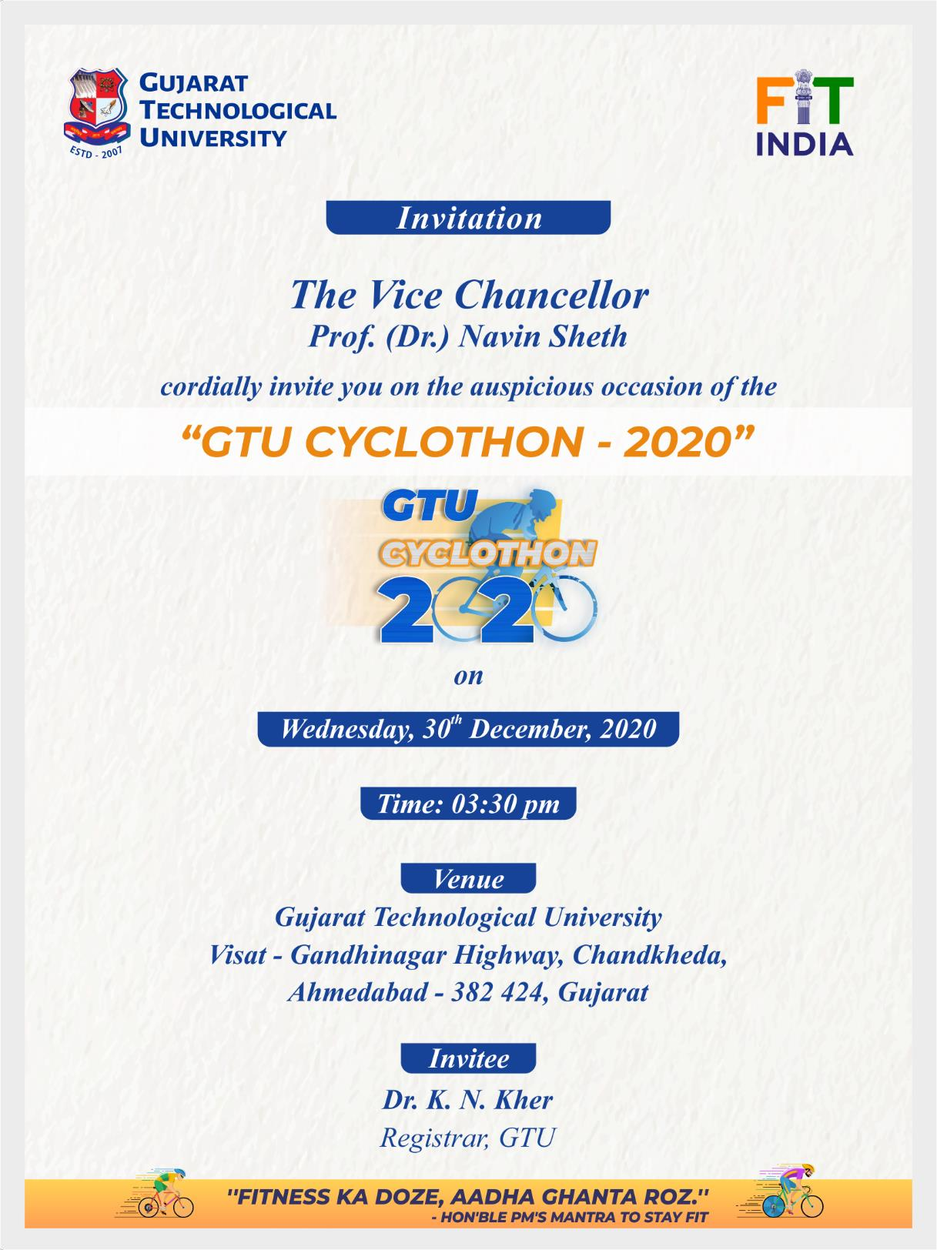

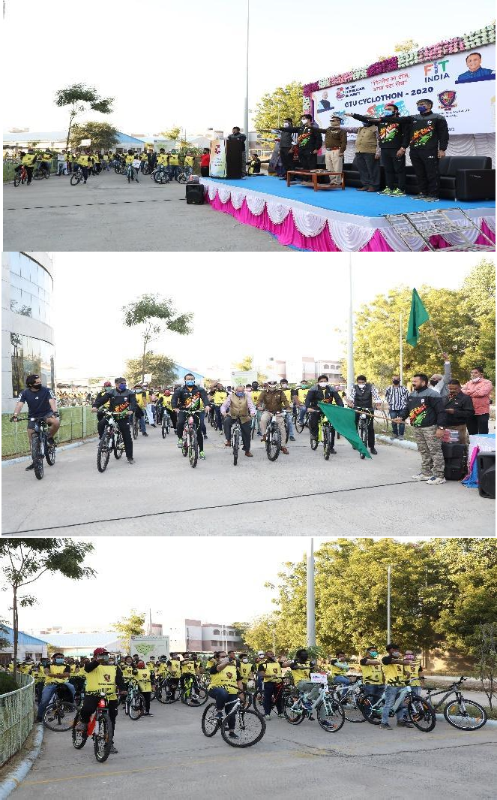
Dr. Aakash Gohil
Sports Officer, GTU
Registrar, GTU
Dr.
Prof. (Dr.) Navin Sheth
K. N. Kher
Vice Chancellor, GTU
Gandhinagar,
Swarnim Gujarat
Ahmedabad,
Sports University Gujarat, India.
Gujarat. India.
<GTU Cyclothon - 2020 > conducted on
<30/12/2020>

Gujarat Technological University was organized a Cycle Awareness Program-“GTU
Cyclothon-2020” as part of "Fit India Movement”. This “GTU Cyclothon-2020” organized by GTU to embody Our Honorable Prime Minister Narendra Modi's motto "Hum Fit to Bharat Fit" "Fit Nation Hit Nation"
““फिटनेस का डोज़ - आधा घंटा रोज़". The Bicycle
Awareness and “Cyclothon-2020”GTU arrange 250 bicycles for a Single day. Gives certificate of Participants by GTU.

Invitees Dignitaries
Mr. Sanjay Srivastava Dr. Arjunsinh Rana
Police Commisioner, Vice Chancellor

